Pir Mehr Ali Shah

**Arid Agriculture University, Rawalpindi**

**University Institute of Information Technology**

Course Code.: **CS-577** Course Title: **Computer Networks**

Degree: **BS-CS** (4AMor) Total Marks: ____10________

Date: **05-June-2023** Signatures: _______________

**Assignment No. 4**

**Instructions: Solve all Questions and submit assignment in soft form.**

**Question N0. 1**

Why doesn’t collision detection work well in wireless networks? (describe a scenario where this doesn’t work.)

**Question N0. 2**

1. Fill and Label the following figure for TCP Header structure.
2. Draw and fill (??) the Seq no and ACK no for the following figure.

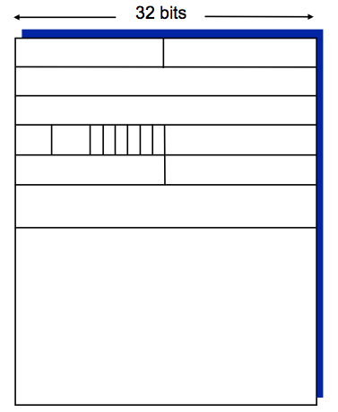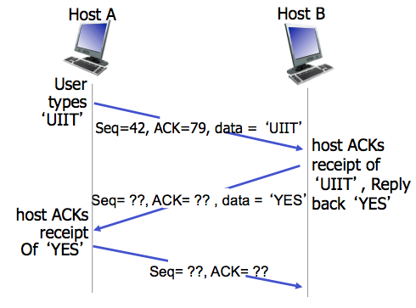

**Question N0. 3**

Draw the network diagram using following addressing Table.

